**ST.XAVIER’S COLLEGE**

MAITIGHAR, KATHMANDU



**Computer Graphics**

Assignment #9

Submitted By:

Abhishek Tamrakar

013BSCCSIT003

2nd year/ 4th semester

Submitted to:

|  |  |
| --- | --- |
| Er. Anil Shah  Lecturer  Department of Computer Science |  |

**Statement:**

**PERFORM TRANSFORMATION IN THE IMAGEBY SHEARING**.

**Algorithm:**

1. Get the width and height of the source image
2. Get parameter for shearing axis (1 for x-axis, 2 for y-axis)
3. For each point i in width

For each point j in height

If parameter==1

The translated point (x’, y’) is given by

a=i+j*sx

If parameter==2

The translated point (x’, y’) is given by;

b=j+i*sy

Plot the points (x’, y’) with the same color as source in destination

1. Stop

**Source Code:**

//---------------------------------------------------------------------------

#include <vcl\vcl.h>

#pragma hdrstop

#include "shear2.h"

//---------------------------------------------------------------------------

#pragma resource "*.dfm"

TForm1 *Form1;

float x,y,sx,sy,a,b;

//---------------------------------------------------------------------------

__fastcall TForm1::TForm1(TComponent* Owner)

: TForm(Owner)

{

}

//---------------------------------------------------------------------------

void __fastcall TForm1::Edit1Change(TObject *Sender)

{

sx=StrToFloat(Edit1->Text);

}

//---------------------------------------------------------------------------

void __fastcall TForm1::Edit2Change(TObject *Sender)

{

sy=StrToFloat(Edit2->Text);

}

//---------------------------------------------------------------------------

void __fastcall TForm1::shearClick(TObject *Sender)

{

x= Image1->Width;

y=Image1->Height;

int a,b;

for(int i=0;i<=x;i++)

{

for(int j=0;j<=y;j++)

{

a=i+j*sx;

b=j+i*sy;

Image2->Canvas->Pixels[a][b]=Image1->Canvas->Pixels[i][j];

}

}

}

//---------**Output:**

**On X-Axis:**

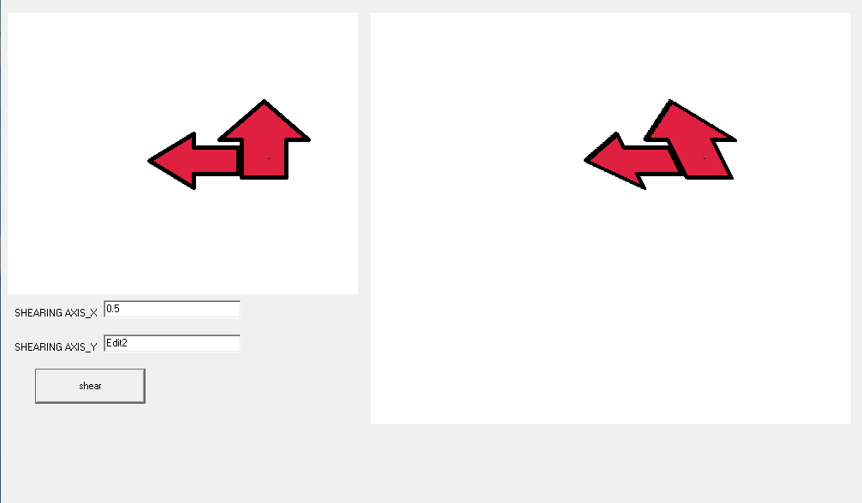

**On Y-Axis:**

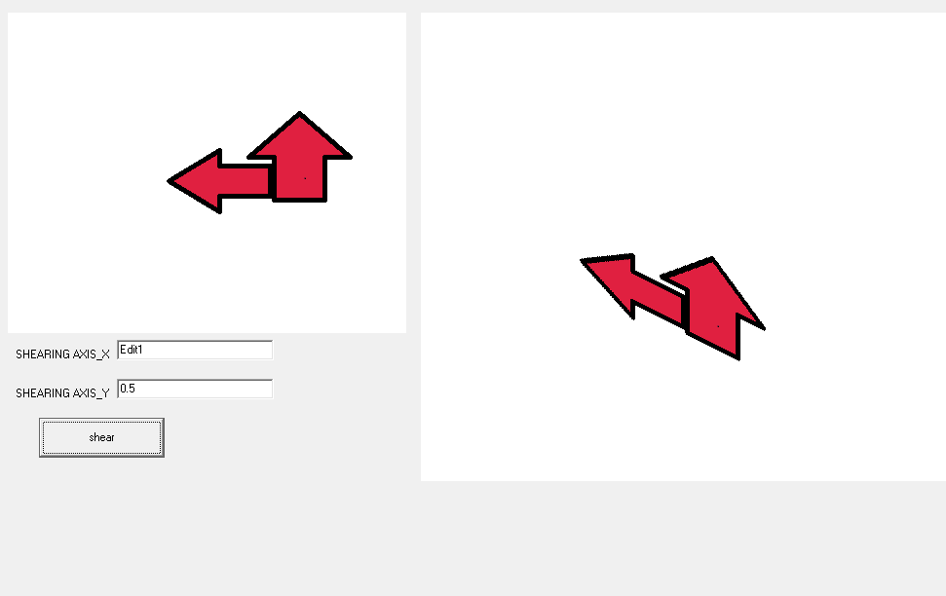

**Conclusion:**

Hence, shearing of object was performed using C++ Builder.